Banknote Destruction Machine
Paper Shredder with Integrated Baler and Compactor
YUEDU Brand | Model: BM3002P-9075
Banknote Destruction Machine | Integrated Baler and Compactor | Output
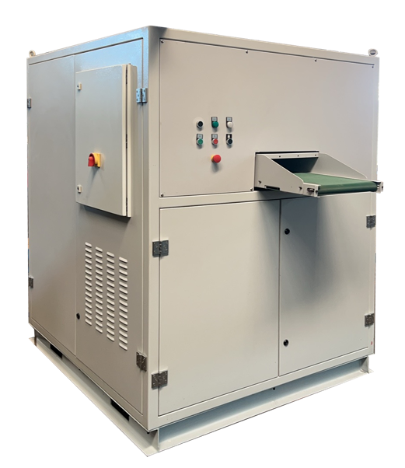 | 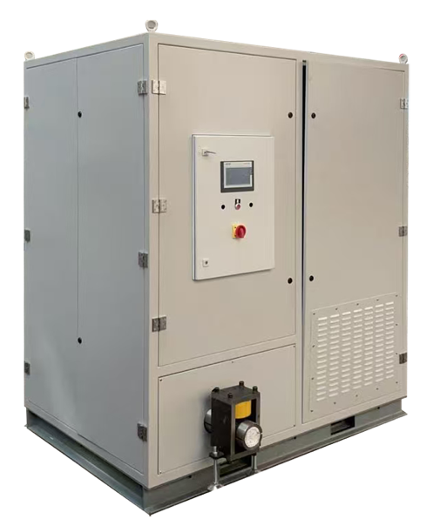 | 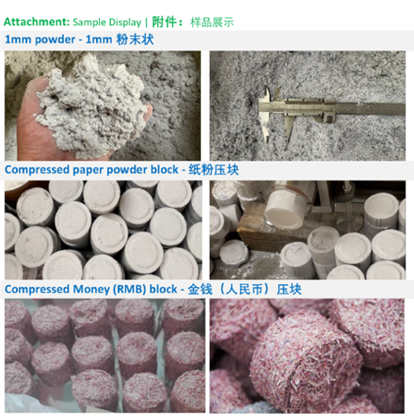
Shredder Specifications
• Single Feed Capacity: 100 sheets; Hourly Shredding Capacity: 100-150KG/H
• Feed Width: 420mm
• Power: 22KW
• Dimensions: 3380*1440*2220mm
Shredding Process:
• Two-stage shredding with dual blade sets.
• Dimensions: 1480*1440*1850mm
• Output: 3mm particles: 100-150KG/H; 1mm particles: 75KG/H
Compacting Process:
• Compressed block diameter: 90mm*40mm; Compacting output: 75KG/H
• Dimensions: 1900*1400*2220mm
User Case: Banknote Shredder and Compactor Combo Machine
Overall Image | Compactor Section | Output | YouTube video | 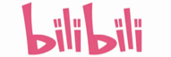bilibili video
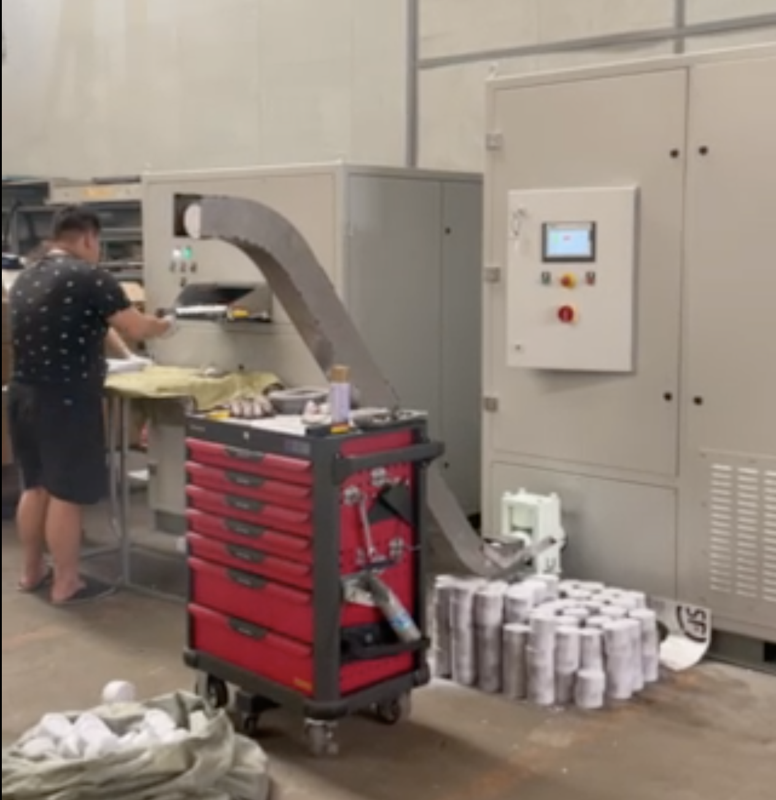 | 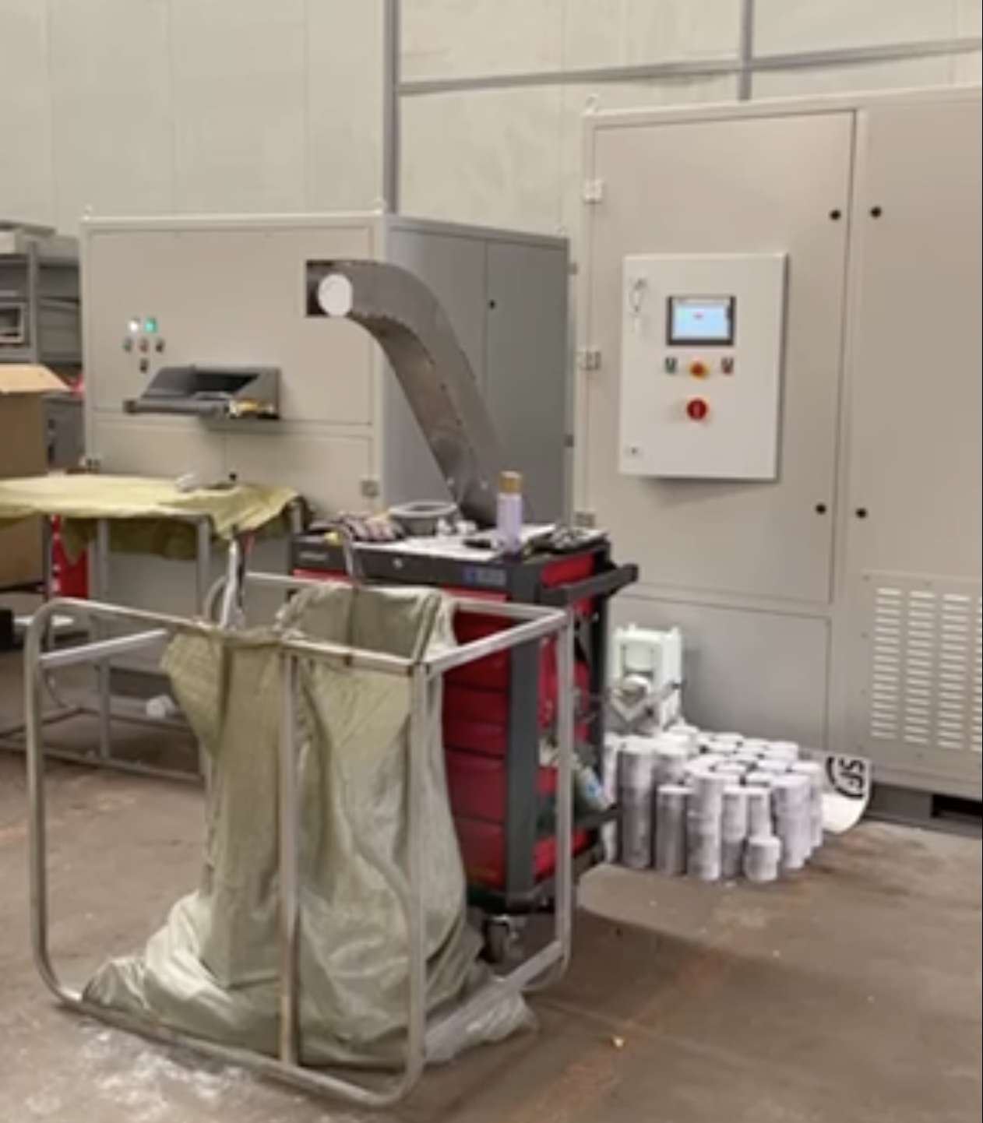 | 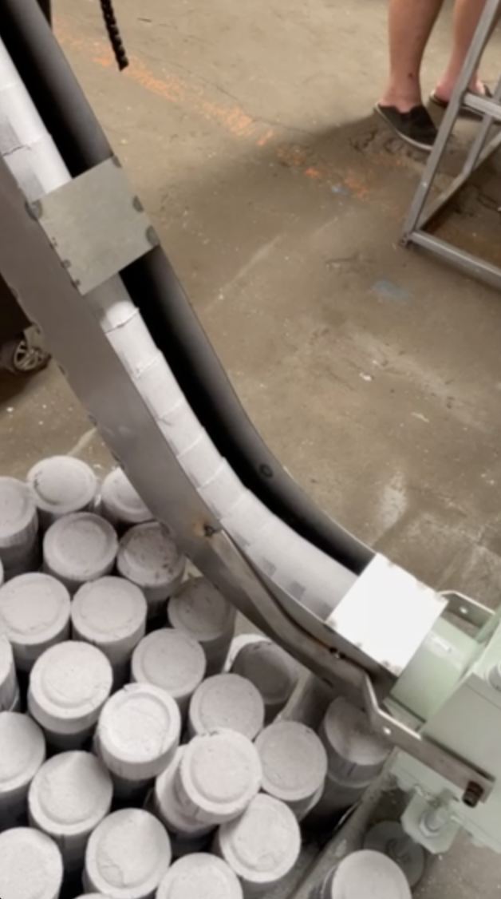 | https://youtu.be/OnOKqf-vkCA  https://youtube.com/shorts/5-dmXbM1Wpw | https://b23.tv/Go7TGFH  https://b23.tv/ToFqYLg
Compactor Selection Table:
纸张粉碎机配套压块机选型表：
 | Plan 1  方案1 | Plan 2  方案2
Model  型号 | YKJ90-75 | YKJ90-250
Image  压块机主机图 | 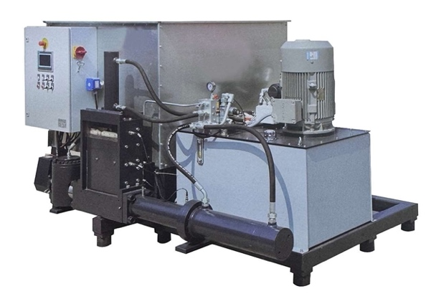 | 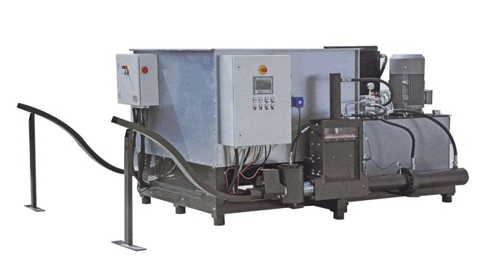
Features  特点 | Output Ports: 1  Hourly Capacity: 75 kg/hour  1个出料口  每小时产量75KG | Output Ports: 2  Hourly Capacity: 250 kg/hour  2个出料口  每小时产量250KG
Specifications  参数 | Compaction Diameter: 90mm  Compactor Output: 75 kg/hour  Motor Power: 11kW  Machine Weight: 1000kg  Dimensions: 1700mm x 2300mm x 1400mm  压块直径：90mm  产 量：75kg/H  马达功率：11kw  机器重量：1000kg  外形尺寸:1700*2300*1400 | Compaction Diameter: 90mm  Compactor Output: 250 kg/hour  Motor Power: 45kW  Machine Weight: 2200kg  Dimensions: 2700mm x 2300mm x 1400mm  压块直径：90mm  产 量：250kg/H  马达功率：45kw  机器重量：2200kg  外形尺寸:2700*2300*1400

